Project Design Phase-II
Data Flow Diagram & User Stories

Date | 01 October 2026
Team ID | SWTID-2026-7816
Project Name | Auto Ticket Classification using Flow Designer
Maximum Marks | 4 Marks

Data Flow Diagrams:
A Data Flow Diagram (DFD) is a traditional visual representation of the information flows within a system. A neat and clear DFD can depict the right amount of the system requirement graphically. It shows how data enters and leaves the system, what changes the information, and where data is stored.
Example : DFD Level 0
Example: (Simplified)
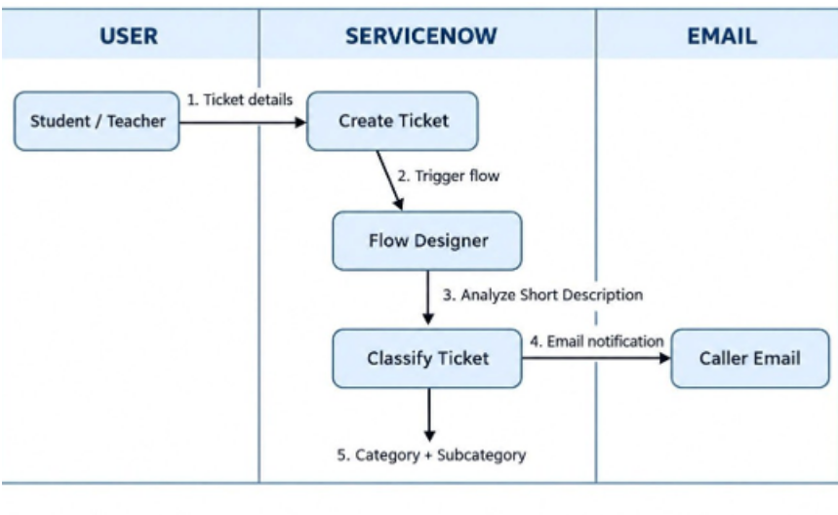
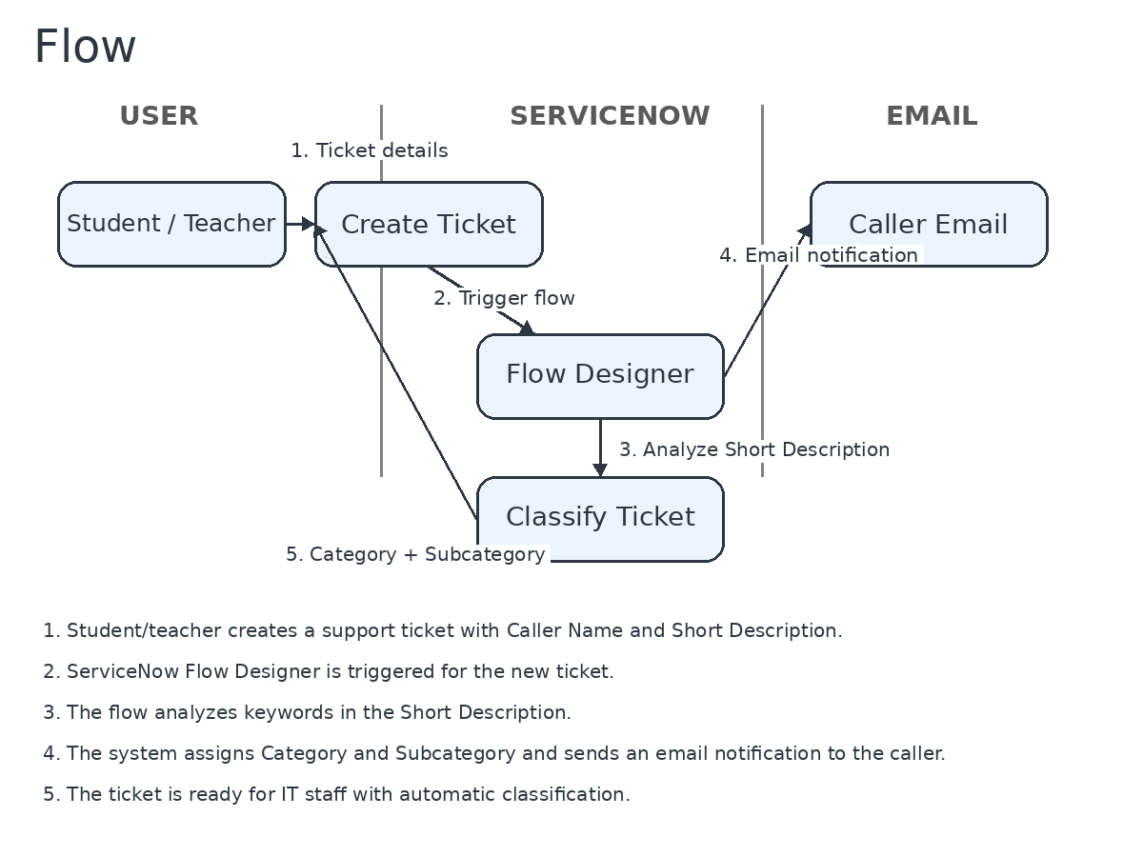

User Stories
Use the below template to list all the user stories for the product.
User Type | Functional Requirement (Epic) | User Story Number | User Story / Task | Acceptance criteria | Priority | Release
Student / Teacher | Ticket Creation | USN-1 | As a student or teacher, I can create an IT support ticket with Caller Name and Short Description. | A new IT support ticket is created. | High | Sprint-1
 | Ticket Notification | USN-2 | As a student or teacher, I can receive an email notification after creating a ticket. | I receive the ticket creation email. | High | Sprint-1
 | Automatic Classification | USN-3 | As an IT support staff member, I can have the issue type identified from the Short Description. | The issue type is identified. | High | Sprint-1
 | Automatic Classification | USN-4 | As an IT support staff member, I can have Category and Subcategory assigned automatically. | Correct Category and Subcategory are assigned. | High | Sprint-1
IT Support Staff | Ticket Processing | USN-5 | As an IT support staff member, I can use automatically classified tickets instead of manually reviewing each request. | Manual classification work is reduced. | High | Sprint-2
IT Support Staff
Administrator
ServiceNow Flow Designer

